## Generic

REPL

Read Evaluate Print Loop

### IDE

jupyter

spyder

VScode

visual studio

IDLE

pycharm

### Basics

class

### interpreters

Cpython

jython → JVM

### keywords

if elif else

for while

break continue pass

True False

### comments

# single line

docstrings multi line

## Data Types

int

float

str

bool

True

False

complex

imaginary

## Operators

### arth

+

-

/

*

% modulo (remainder)

=

// floor division

** power of

#### multiple assignment

x = y = z = 100

x , y , z = 100, 200, "john snow"

### relational

<

>

<=

>=

==

!=

### logical

and

or

not

### bitwise

&

|

<<

>>

~

^

### identity

is

is not

### membership

in

not in

## Functions

### general

print()

type()

id()

range()

### conversion

str()

int()

float()

list()

tuple()

set()

dict()

### sequence

sorted()

len()

min()

max()

sum()

any()

all()

map()

filter()

zip()

### lambda

## strings

### features:

text data

double quotes or single quotes

index

negative index

IndexError

slice

part (or whole)

no IndexError

step

| I | D | L | Y |
| --- | --- | --- | --- |
| 0 | 1 | 2 | 3 |
| -4 | -3 | -2 | -1 |

immutable

### string functions

capitalize() lower() upper() title()

count() index()

isnumeric() isalpha() isalnum()

isupper() islower()

split() splitlines()

### escape sequences

\n new line

\t

\b

\v

\\ \

\” “

### formats

r raw string

%()

.format()

f f-strings (recommended)

### doc-strings

""" """

''' '''

used as:

regular string

multi-line comment

documentation

## list

features:

any data

[ ]

index

negative index

IndexError

slice

part (or whole)

no IndexError

step

mutable

nesting

### list functions

count() index()

insert() append() extend()

remove() pop() clear()

sort() reverse()

copy()

## tuple

features:

any data

( )

index

negative index

IndexError

slice

part (or whole)

no IndexError

step

immutable

nesting

### tuple functions

count() index()

## set

only unique members

unordered

no index

mutable

members:

immutable

int, str, tuple

nesting

features:

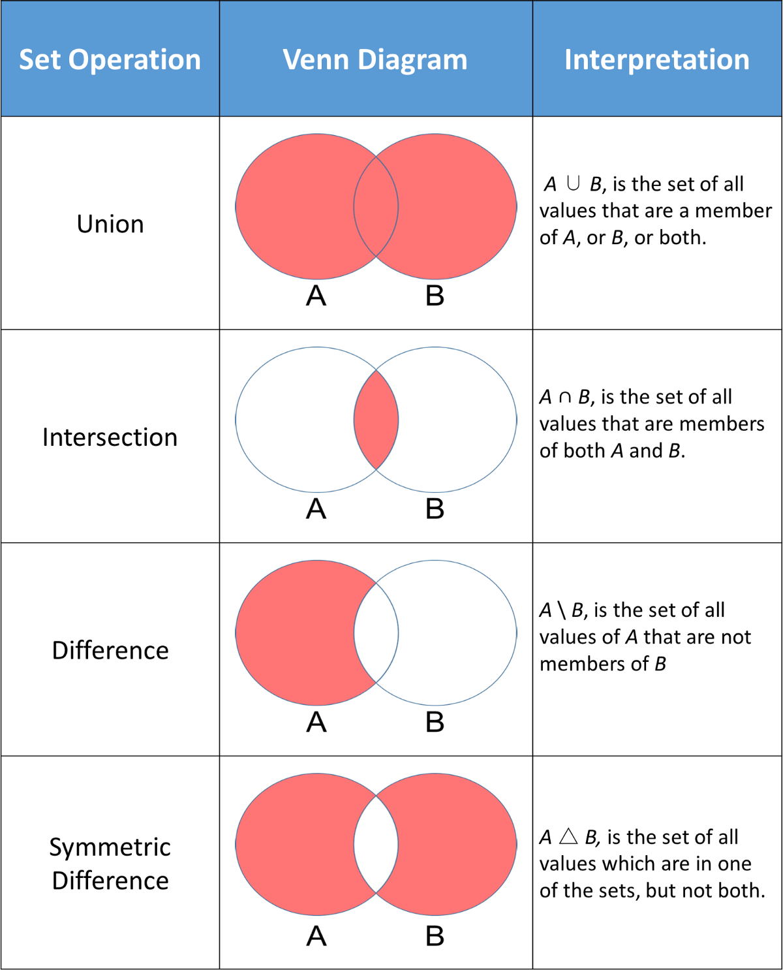

## dict

key:value

key:

index

unique

immutable

values:

anything (can be mutable)

mutable

## flow control

### if

if elif else

### false

0

0.0

'' ""

[ ]

{ }

False

None

### while

while else

break continue

### for

for in else

break continue

1. sequences
2. with range

## user defined functions

def global return

### return values

default is None

### arguments

any number, any data type

default arguments

variable number of arguments

arbitrary

args

kwargs

named arguments

## misc

### comprehensions

## modules

### ways of import

1. import colour

colour.blue()

colour.yellow()

colour.green()

1. from colour import blue, yellow

blue()

yellow()

~~green()~~

1. from colour import *

blue()

yellow()

green()

1. import colour as c

c.blue()

c.yellow()

c.green()

1. from colour import blue as b

b()

## File Programming

#### file types

text files

json

csv

yaml

excel

xml

### text files

UTF-8

open

with open

#### modes

r read

w write

always open it like a new file

a append

r+ read & write

b binary

#### functions & attributes

open

close

read()

readlines()

write()

writable()

readable()

closed

tell()

seek()

### json

json.load()

json.dump()

## exception handling

try

except

1. exception occurs, handled

except block

finally block executes

code continues

1. exception never occurred

else block executes

finally block executes

code continues

1. exception occurs, not handled

finally block executes

code crashes

extras:

command line args

exception handling

excel

graphs or plots (histogram)

linked list

re